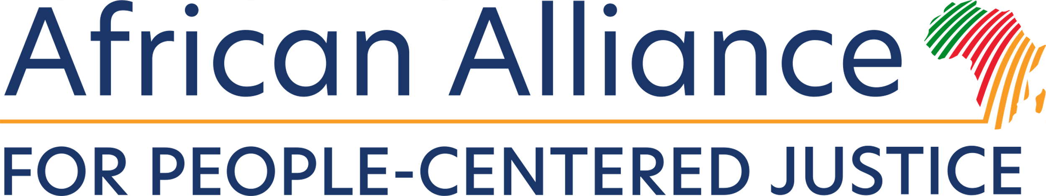

Supporting the nexus between justice and open governance through a people-centered approach

**Concept Note**

24 March 2025

Time: 3:30 – 4:45 pm

OGP Africa and Middle East Regional Meeting, Nairobi, Kenya

Venue: **Radisson Blu Upperhill Nairobi (Mt. Kenya 3)**



Background

The [Open Government Partnership](https://www.opengovpartnership.org/policy-area/justice/) (OGP) works to expand responsiveness, accountability and inclusion into all systems of justice. For members of OGP, justice is a popular policy area for reform that has become an even greater priority in recent years.

According to OGP, investing in open and accessible justice institutions allows citizens to better defend their rights, demand access to public services, and protect their ability to participate in democratic processes. National-level institutions, such Ministries of Justice, as well as institutions at the ground level, such as court systems and legal assistance organizations, all have a role to play in delivering justice services and should be engaged in designing solutions to people’s justice problems.

Launched in November 2024, the [African Alliance for People-Centered Justice](https://www.sdg16.plus/african-alliance-for-people-centered-justice/) (AAPCJ) is a high-ambition coalition of governmental, intergovernmental, and nongovernmental organizations that seek to promote the understanding and use of people-centered approaches to justice in Africa. It was created to mainstream the concept of people-centered justice, supporting local and national actors in implementing policies that contribute to the reduction of the justice gap while fostering equal access to justice for all.

People-centered justice emphasizes practical, locally relevant solutions that directly tackle the barriers people face in accessing justice, especially marginalized and vulnerable groups. It relies on data driven approaches that considers people’s most pressing justice needs and fosters community-driven solutions and grassroots participation.

The AAPCJ seeks to host a session during OGP’s Africa and Middle East Regional Meeting in Nairobi, Kenya to illustrate the symbiosis that exists between access to justice and open governance and how a people-centered approach to justice serves as a catalyst towards the realization of both of these objectives.

Session Description

The OGP Africa and Middle East Regional Meeting is an excellent opportunity to **foster collaboration and exchange** at a timewhen **transparency, accountability, and citizen engagement are more critical than ever in strengthening democratic governance across the region.**

The 75-minute session organized by the [African Alliance for People-Centered Justice](https://www.sdg16.plus/african-alliance-for-people-centered-justice/) will be structured as an interactive panel discussion featuring representatives from government, the judiciary and grassroots justice workers. The focus will be on **exploring best practices, innovations and lessons learned** from Africa, in advancing open government and people-centered justice. This will provide an opportunity for interregional learning and identifying actionable strategies to address shared challenges.

Agenda and Speakers

|  |  |
| --- | --- |
| 7 minutes | **Opening of the session by the Moderator**, Themba Mahleka, Pathfinders for Peaceful, Just and Inclusive Societies |
| 7 minutes | **Justice Joseph Sergon**, National Steering Committee on Implementation of Alternative Justice Systems Policy, Kenya |
| 7 minutes | **Aimee Ongeso,** Grassroots Justice Network |
| 7 minutes | **Clifford Msiska,** PASI/ African Centre of Excellence for Access to Justice |
| 40 minutes | **Open discussion with audience participation** moderated by Themba Mahleka, Pathfinders |
| 7 minutes | **Closing Remarks by Marie Duprez, HiiL** |